Booze ‘R’ Us

Introduction
Our client, Booze ‘R’ Us, owns a large number of liquor stores in Iowa. Using state alcohol sales data, demographic data and population data, we sought to predict liquor sales and find which products sold the best, and where. At Pembroke Data Consultants (PDC), we want our client to make well-informed decisions about liquor distribution, stock, and company expansion. Currently the data provided is Iowa Alcohol purchases from different stores from 2012 to present. In addition to the provided data, we extracted data from the census bureau to give a clear picture of the amount of alcohol per capita either pre-existing or potential new stores would purchase per year. We additionally focused on the American Community Survey DP03, which provides insights into the economic characteristics of communities in the United States. It is conducted annually and gathers information on various social, economic, housing, and demographic factors. This data is essential for understanding the economic health of communities and identifying trends and disparities.

Data
The Iowa state alcohol sales data provides us with every purchase a liquor store in Iowa has made since 2012. From these transactions, we are able to see where the store is located, the quantity of alcohol purchased, the price of the alcohol and when the transaction took place. From this, we were able to interpret each liquor store’s city, county, year from date (transaction), category_name (type of alcohol), sum sale dollars, sum sale liters, and price per liter.
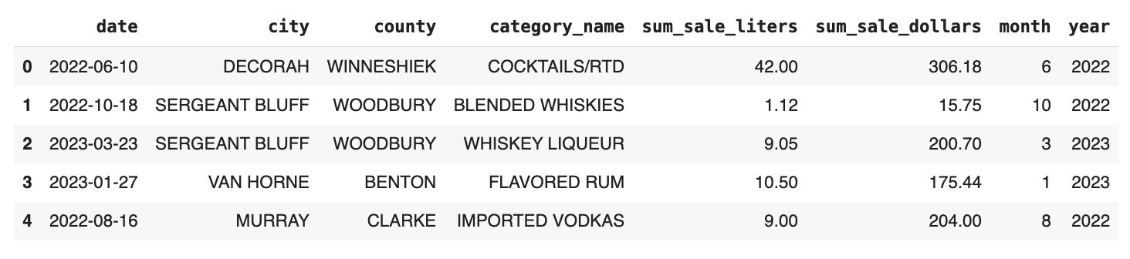
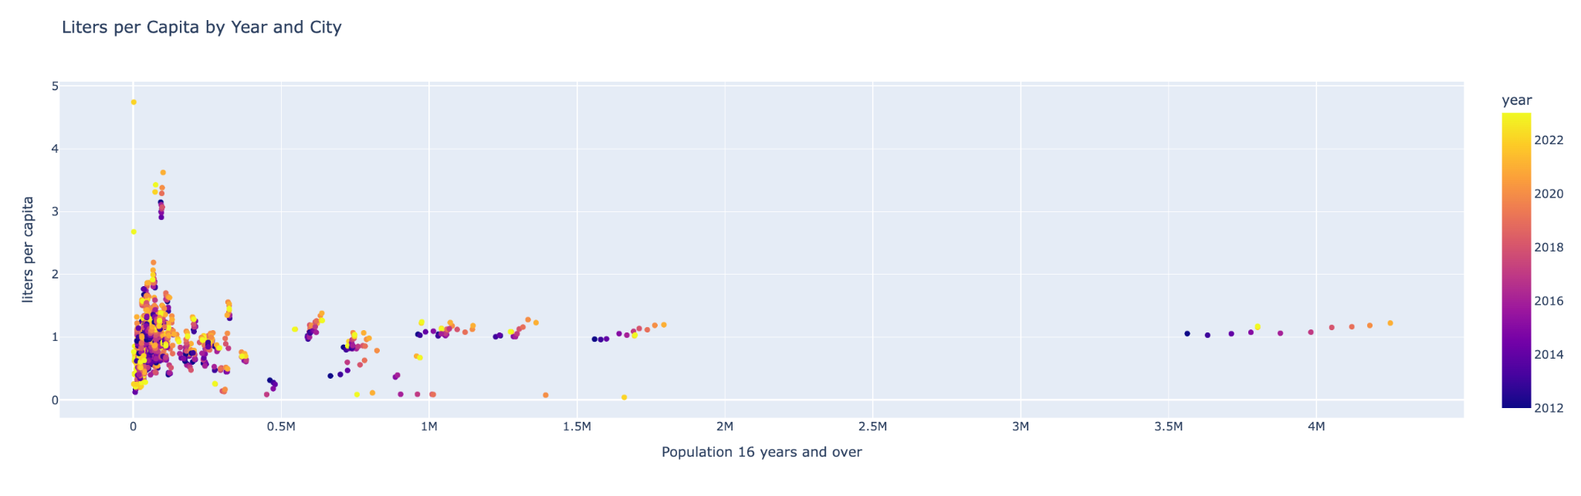
These indicators specifically, provide a coherent picture of each transaction, without having to look at each individual store and instead looking at each city as a whole. From the census data, we removed attributes such as healthcare insurance, percentage of families with income under the poverty line, and removed demographics that specified families that owned children between different age ranges. We felt this was an invasion of privacy and hindered our integrity at PDC. We then divided total liters sold by the population (aged 16 or older) to calculate liters sold per capita, and categorized transactions by the type of alcohol sold to each liquor store.
We decided to fit our data using ridge regression to help single out which coefficients are the least important in the model by making them closer to zero. Before we drop correlated predictors there are seventy four predictors that can be fit to liters per capita. In order to get the best understanding we decided to fit two separate models. The first being grouped on city, year, and category name, and the second being grouped on county, year, and category name. After dropping the highest correlated predictors, we were left with years, total sale dollars, and price per liter. In regards to our demographic interpretation, population aged 16 or over, armed forces as an occupation, public transportation as main form of transportation, other means, working from home, and unpaid family workers as predictors. Alcohol category types including bourbon, brandy, gin, liqueur, miscellaneous, rum, schnapps, scotch, tequila, vodka, and whiskey were also predictors. Some of our largest predictors included Whiskey, with a coefficient of 8.15, Vodka with a coefficient of 5.926, and population aged over 16, with a coefficient of 2.36. After we grouped based on county, year, and category name, we chose to cross-validate our model and fit liters per capita. From this we were able to see that the county had an r^2 value of 0.52, telling us our model is able to moderately predict on our testing data. With a mean square average around 20, we feel confident in our model’s predictions as this is a reflection of the accuracy of our results since the liters per capita encapsulates the county as a whole, which is typically quite large. The tables below encapsulate the same range, the left is the results after we ran our model based on county, while the table on the right

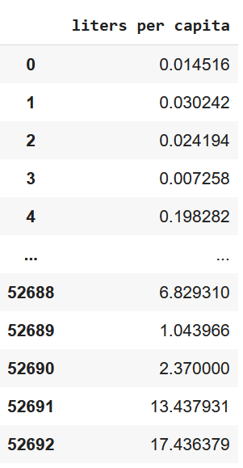
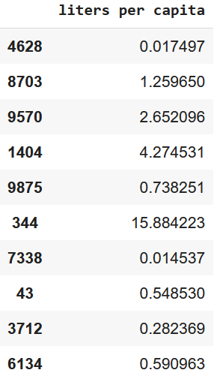

This calls us to advise Booze ‘R’ Us to emphasize sales and boost stability in their current or potential new stores based on what county they are based, as opposed to specific cities. Although our model, when run grouped on cities, received a 0.27 r^2 and 3 MSE after cross validation, this does not particularly signal to us at PCD that emphasis on liquor store city is necessarily more advantageous. Here, we want to remind our client that liters of liquor sold per capita for each liquor category, the area of cities is obviously much smaller than counties, and consequently, so are liters per capita. The table on the right indicates that an error of three could lead to three extra for the really small liters per capita for index zero.
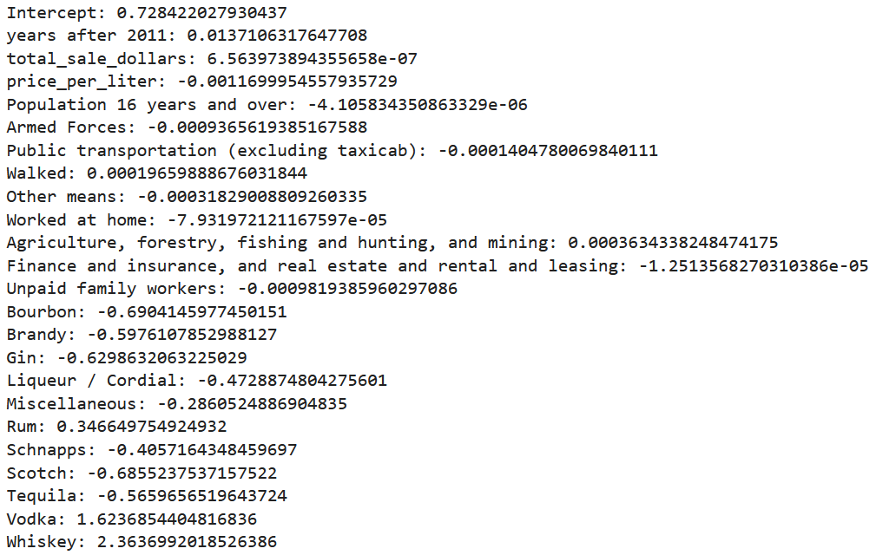

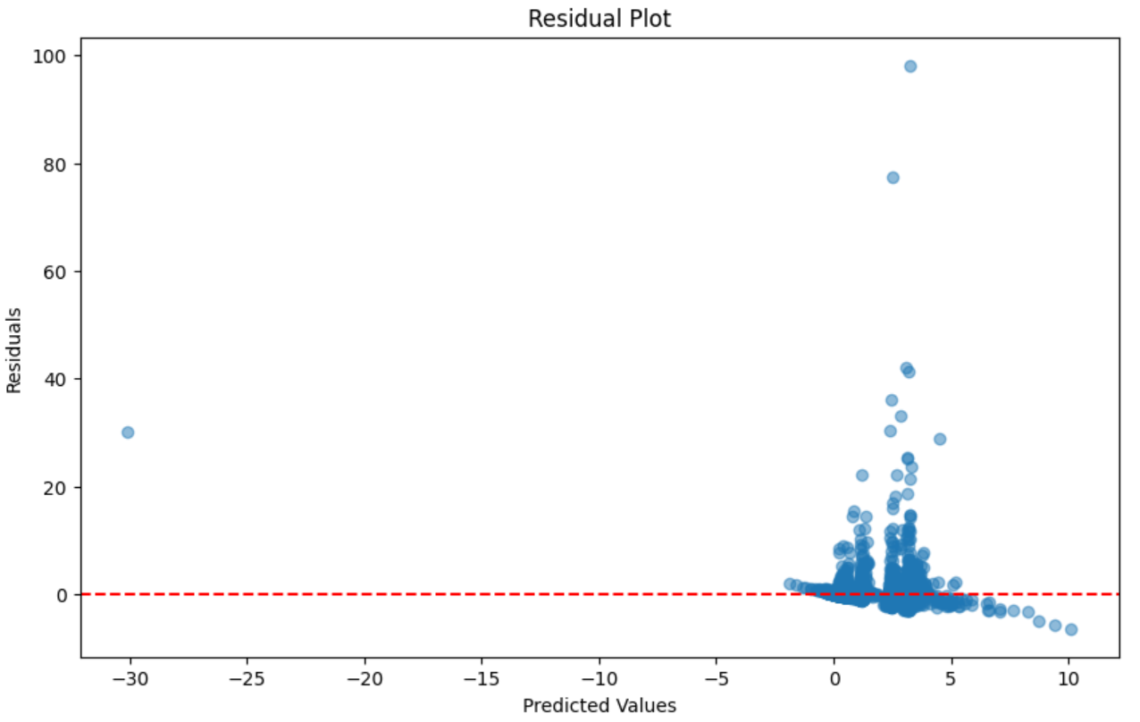
Model coefficients are an additional product we are pleased to offer our client. With these attributes and their respective coefficients, the Booze ‘R’ Us team can calculate the value of liters per capita for a year in a specified county. To better understand the model, your team will compile economic characteristics from specific areas that you would want to expand in. These predictors are then multiplied by the coefficients, as an example, if ten thousand people have walking as their main form of transportation, our predictors indicate liters of alcohol sold per capita would increase by one point nine. After selecting one, or multiple predictors, a type of alcohol. Again, for exemplary reasons, if ten thousand people in a specified county used walking as their main form of transportation, vodka liters per capita would increase by one point sixty-two. We advise against using multiple alcohol categories in the same prediction equation, as it will skew the amount of alcohol a store should buy.
The majority of the points in the residual plot above are near the zero axis. This further increases our confidence in our product to approximate the amount of liters per capita in different counties across the United States. Here, we note that counties predicted to have higher or lower liters per capita should motivate or advise against expansion.

Conclusion
From our findings, we are happy to provide our client with the necessary material for them to make well-informed decisions in regards to how they stock their existing stores, promote specific products within their stores, and potentially expand their company. It is important to note this model is not built to predict sales. It instead should be used to aid Booze ‘R’ Us in deciding where to build new stores based on how many liters per capita the stores collectively are buying in the surrounding area. An important distinction to make is that this number is not a guarantee in store profit.

